Module One: Earning an income Name:

Key terms and definitions
Term | Definition
Australian Business Number (ABN) | An identifying number that every Australian business must have.
Award | Employment contract based on a court decision outlining minimum pay and conditions.
Employment Contract | An agreement about wages and conditions of work.
Goods and Services Tax (GST) | A broad-based tax, currently at 10 per cent, on most goods and services in Australia. Some essential items are exempt, e.g. fresh fruit and vegetables.
Income | Money obtained from working, interest, dividends, selling assets and other sources.
Income tax | Money paid from earnings to the Australian Government at a progressive rate, i.e. when you earn more money, you pay a higher rate of tax. Current tax rates can be found at Australian Taxation Office
Occupation | A job.
Tax file number | An identifying number received after registration with the Australian Taxation Office. This is needed for employment.
Tax threshold | Levels of income above which the proportion of tax you pay increases. Current tax rates can be found at Australian Taxation Office
OECD | Organisation for Economic Cooperation and Development aims to promote policies that will improve the economic and social well being of people around the world.

Task 1
- Visit the website Australian Government Job Outlook and investigate different occupations listed alphabetically. Have a look at the key features of being a checkout operator and office cashier. Record the following information in the table below:
Occupation: Checkout operator/office cashier
Weekly earnings full-time
Job prospects
Gender breakdown
Main age group
% Working full-time
Typical role and working conditions
Now repeat this exercise for an occupation of your choice.
Occupation:

Weekly earnings full-time
Job prospects
Gender breakdown
Main age group
% Working full-time
Typical role and working conditions

- Minimum conditions at work can come from registered agreements, awards or legislation. When an award covers a business and the work the employee does, then the minimum pay and conditions in the award will apply. There are 122 awards that cover most people working in Australia. Where no award or agreement applies, the minimum pay and conditions in the National Employment Standards (NES) will apply. Visit Fair Work Commission General Retail Industry Award 2010 and scroll through the site to get an idea of how comprehensive this award is. This is the award that would cover checkout operator and office cashiers.
Questions | Answers
What is a part-time employee?
How much more per hour than a full-time employee does a casual employee receive?
What is the minimum weekly wage for a Retail Employee Level 1?
What percentage of the full-time weekly rate of pay would an employee who is 17 years old receive (Junior rates)?
Work out the amount the Junior described about would receive per week.

- Employers must give you a payslip within one day of paying you. Have a look at the payslip below and label the following parts:
- Net pay
- Superannuation fund
- Date
- Employee’s name
- Gross pay
- Deductions
- Hourly pay rate
- Tax paid
- Employer’s details
Sample pay slip:
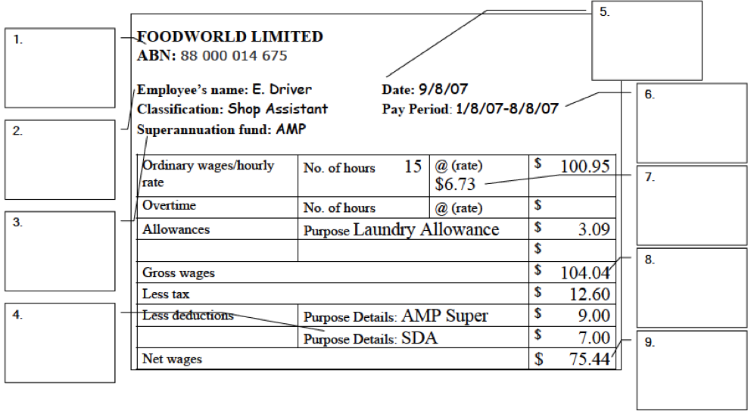
- Discuss with the class:
- The advantages and disadvantages of part-time or casual employment. Think about the issues related to pay, hours worked, termination of employment and flow-on effects like trying to get a loan or a credit card.
- Which type of employment would you choose?
Notes

- Employers must provide you with a payment summary within two weeks after the end of the financial year. Have a look at the payment summary below and visit Australian Taxation Office and look up the section ‘Individual’.
Sample payment summary:
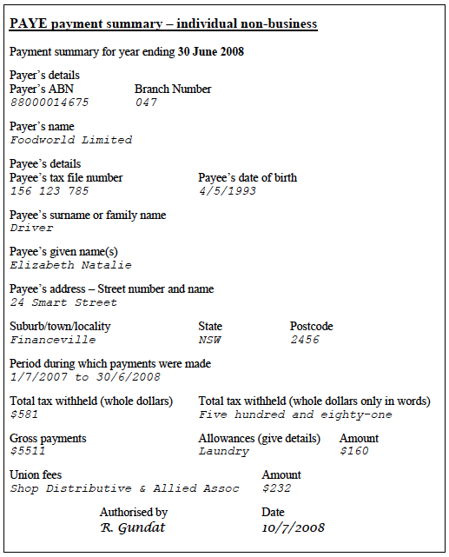

Questions | Answers
Describe how you get a tax file number.
What are five reasons you need a tax file number?
How much tax did Elizabeth pay?
What percentage of her income did she pay in tax?
Find the tax calculator on the website and find out how much tax you would pay if you earn:
i. $8,000

ii. $22,000 this year.

What is the tax-free threshold?

Opinions about tax:
- Tax is a necessary evil.
- We pay so much tax for so few services.
- Higher tax rates on higher incomes just make people move income offshore.
- High marginal rates of tax for those earning more than $150,000 encourage people to plan schemes to avoid paying tax.
- Australia’s average tax rate is around 31%, lower than the average of 37% for most other industrialised countries.
- In countries where the tax collected is low there are many more children in poverty.
- When I pay tax I am contributing to a society I would like to live in.
- There are only two things in life that are certain: teachers and taxes.
- Tax is for the common good and the common people.
- The GST hurts those on lower incomes because they spend much more of their income.
- We should all pay the same tax rate because everyone benefits equally from services such as garbage collection, roads, railways and streetlights.
- When you have freedom, you should also take responsibility.
- Those on higher incomes and businesses making big profits should pay higher tax rates.
- Australia spends a lower proportion of national income on social security payments than all 16 OECD countries except Japan, Ireland and the US.
- We should all pay more tax because the health and education systems are suffering.
- The middle classes keep the country going because they pay all the taxes, while the poor get it all back through welfare.
- Most rich people pay little or no tax.
- Taxes turn people off working harder.
- If people are unhappy with paying tax to help the community, then we need to change their attitude.
- High taxes reduce business incentives.
- People on higher incomes shouldn’t have to pay higher rates of tax because they work harder than people on low incomes.

Where do your taxes go?
Australians pay at least 125 different taxes each year. The exact number is hard to work out and may be higher than this. Of these, around 100 go to the federal government, including up to 70 agricultural taxes. State governments collect around 25 of these taxes, and local government collects council rates, licence and permit fees.

Each level of government is responsible for providing services and they each raise money through taxes or charges to pay for those services. Sometimes more than one level of government share the responsibilities of certain services. Generally the local council looks after public property, such as roads and parks and decides where which natural areas and historic places should be protected. The council looks after garbage and recyclable waste collection, checking cleanliness of restaurants and shops, registering dogs and destroying vermin, street signs and traffic control. Some councils look after libraries, museums and theatres, public halls and swimming pools.

The State Government is responsible for all areas that are not federal responsibilities, but often both levels are involved and the federal government will give the state governments money for their programs. The responsibilities of state governments include education, health, the environment, transport, public works, primary industries industrial relations, community services, sport and recreation, consumer affairs, police services, prisons, and water.

The federal government’s responsibilities include the defence forces, pensions and family support, employment, immigration and customs, post and telecommunications, imports and exports, passports, the media, airports and air safety, income and company taxes.

Task 2
- Read the ‘Opinions about tax’ above and discuss with the class. Answer the following:
Questions | Answers
Where do different levels of government get their money (different taxes go to different levels of government)?
What services do you expect governments to provide and how can they pay for these?

- In groups, prepare a poster, multimedia presentation or video for the class on income tax. To get your information look at this material and other relevant Internet sites. You should:
- Explain what income tax means.
- Talk about some of the reasons why people should pay tax.
- Talk about the different services governments (Local, State and Federal) provide from taxes they collect.
- Explain how more government funding could improve Cooks Hill Campus.
- Conduct a short survey of teachers and/or other adults about why people should pay tax and what they think of Australia’s taxation system.

These are the 2007-08 financial year figures.

